## 1. Introduction

The Radix-2 Single-Path Delay Feedback (SDF) architecture provides an efficient and hardware-friendly design for implementing the Number Theoretic Transform (NTT). This architecture processes one input coefficient per clock cycle and begins generating output coefficients after the internal pipeline stages are filled. Each computational stage includes a butterfly unit paired with a memory block that stores intermediate values. Figure 1 provides a high-level overview of the proposed SDF-NTT architecture.

## 2. SDF Architecture Operation

A butterfly operation in NTT requires two input coefficients spaced by a stage-dependent offset. For a 256-point Decimation-In-Frequency (DIF) NTT, the first stage processes coefficient pairs such as (ai, ai+128) for i = 0 to 127. In the second stage, the offset becomes 64, and this pattern continues until the final stage, where the offset is 1.

Each stage operates in two distinct phases:

1. **Input Phase:** The first half of the coefficients is stored in memory.
2. **Computation Phase:** While the second half of the coefficients is streamed in, the first half is simultaneously read from memory to form butterfly input pairs.

The butterfly output is split into two streams:

* One stream is directly forwarded to the next stage
* The other stream is stored for reuse in subsequent operations

This pattern of operation continues across stages with progressively halving offsets.

## 3. System-Level Architecture

### 3.1 SDF-NTT Before Optimization



*Figure 1: SDF-NTT Architecture Before Optimization*

| **Signal** | **Description** | **Width** |
| --- | --- | --- |
| clk | System clock | 1 bit |
| rst_n | Negative edge reset signal | 1 bit |
| start | Active high enable signal that must be asserted before passing the input data; must remain high until the last output is generated | 1 bit |
| sdf_in | Input data port | 64 bits (parameterized) |
| sdf_out | Output data port | 64 bits (parameterized) |
| done_tick | Flag that becomes high with the last output data | 1 bit |

### 3.2 SDF-NTT After Optimization





*Figure 2: SDF-NTT Architecture After Optimization*

| **Signal** | **Description** | **Width** |
| --- | --- | --- |
| clk | System clock | 1 bit |
| rst_n | Negative edge reset signal | 1 bit |
| start | Active high enable signal that must be asserted before passing the input data; must remain high until the last output is generated | 1 bit |
| sdf_in | Input data port | 64 bits (parameterized) |
| sdf_out | Output data port | 64 bits (parameterized) |
| done_tick | Flag that becomes high with the last output data | 1 bit |

#### Optimization Details

To improve throughput, we applied a 4-stage pipelining technique to the Barrett Reduction unit. However, this introduced a data hazard due to timing mismatches in the pipeline.

#### Resolution Strategy

* A **4-stage register chain** was inserted into the path of the **first input of the butterfly unit**. This aligned the timing between the two butterfly inputs, allowing the first stage to operate correctly.
* After implementing this fix, new data hazards were observed in the subsequent stages due to overlapping data dependencies.
* To resolve this issue, we introduced **a stalling mechanism** for the **enable signal of the first-stage buffer**. Specifically:
  + When the first-stage buffer is filled **for the second time**, the enable signal is temporarily de-asserted.
  + This stall is maintained until the second stage completes its **first fill cycle**, after which the enable signal of the first stage is reasserted again.

This control logic ensures proper synchronization across all stages, allowing the pipeline to operate without data hazards.

## 4. Extending to INTT Support

### 4.1 Reducing Memory for Twiddle Factors

An NTT-Based Nega Cyclic operation requires (n) different powers of the twiddle factor *ψ-*, and similarly, an INTT requires (n) different powers of *ψ-*-1. Each stage of the NTT or INTT uses only a subset of these powers:

For 16points-NTT :

* Stage 1 uses n/16 powers
* Stage 2 uses n/8 powers
* Stage 3 uses n/4 powers
* Stage 4 uses n/2 powers

For 16points-INTT :

* Stage 1 uses n/2 powers
* Stage 2 uses n/4 powers
* Stage 3 uses n/8 powers
* Stage 4 uses n/16 powers

Therefore, an NTT/INTT implementation must store at least 2n twiddle factor powers (n for NTT and n for INTT). To reduce this memory requirement, we exploit the mathematical properties of twiddle factors:

*ψ 2n ≡ 1 (mod q), and ψ n ≡ -1 (mod q)*

Using these properties, we can express:

*ψ -i = ψ 2n · ψ -i = ψ n · ψ n-i = - ψ n-i*

This means that *ψ* -i can be derived using - *ψ* n-i, which is computationally inexpensive in hardware. It only requires a small subtraction circuit to compute the modular inverse of a twiddle factor during the INTT. This optimization reduces twiddle factor storage by 50% at the cost of log₂(n) additional subtraction units.

4.2 Eliminating the Multiplication by n-1

In INTT, the final coefficients must be scaled by n-1 mod q. Although straightforward, this adds n extra operations and increases latency.

To eliminate this overhead, we merge the scaling with the post-processing step using the Number Theoretic Transform with Constant (NWC) method. A technique replaces the final multiplication by n-1 with 2-1 in each butterfly operation. This is efficient for odd primes q, as division by 2 in ℤq can be computed as:

*a / 2 ≡ (a >> 1) + a[0] · ((q + 1) / 2)*

This avoids the need for an extra full-width multiplier by replacing it with two adders in the butterfly unit. We adopted this technique in our implementation to reduce the latency of INTT operations.

## 5. Integrated NTT/INTT Architecture



To extend the functionality of the SDF to support inverse NTT operations in addition to forward NTT, we integrate the NTT butterfly unit with the INTT butterfly unit as shown in Figure 3. This unified approach allows the same architecture to perform both operations efficiently.

**Important Note:** This SDF implementation requires the input data to be in normal order for both NTT and INTT operations, and the output data is generated in bit-reversed order. To enable calculation of INTT after NTT for the same data points using the same architecture, we use an output address mechanism to rearrange the output points in normal order before feeding them back to the input.

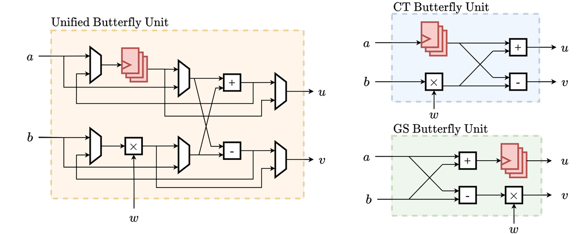

*Figure 3: Integrated NTT/INTT Butterfly Unit*

## 6. Complete System Overview





*Figure 4: Complete SDF-NTT/INTT System Architecture*

| **Signal** | **Description** | **Width** |
| --- | --- | --- |
| clk | System clock | 1 bit |
| rst_n | Negative edge reset signal | 1 bit |
| ntt_logic_enable | Active high enable signal to enable the data path for the ntt operation that must be asserted before passing the input data; must remain high until the last output is generated | 1 bit |
| Intt_logic_enable | Active high enable signal to enable the data path for the intt operation that must be asserted before passing the input data; must remain high until the last output is generated | 1 bit |
| start | An active high signal that must be asserted when the first input data is ready to be sampled.  When it is high at a certain clk edge the system captures it and start its operation and the system does not listen to it any more until the operation is finished | 1 bit |
| sdf_in | Input data port | 32 bits (parameterized) |
| sdf_out | Output data port | 32 bits (parameterized) |
| output_address | Specifies the order of each output point to be stored in memory | log₂(n) bits, where n is the polynomial size |
| In_address | Specifies the address of each input point if they are read from a memory | log₂(n) bits, where n is the polynomial size |
| done_tick | Flag that becomes high with the last output data | 1 bit |
| Data_valid | Flag that becomes high with each output data point | 1 bit |
| busy | Flag that becomes high when the system samples the first input until the last output comes out | 1 bit |

## 7. Simulation Results

### 7.1 Python Model Validation

The architectural correctness was confirmed through Python model validation, ensuring that the theoretical framework matches the practical implementation.

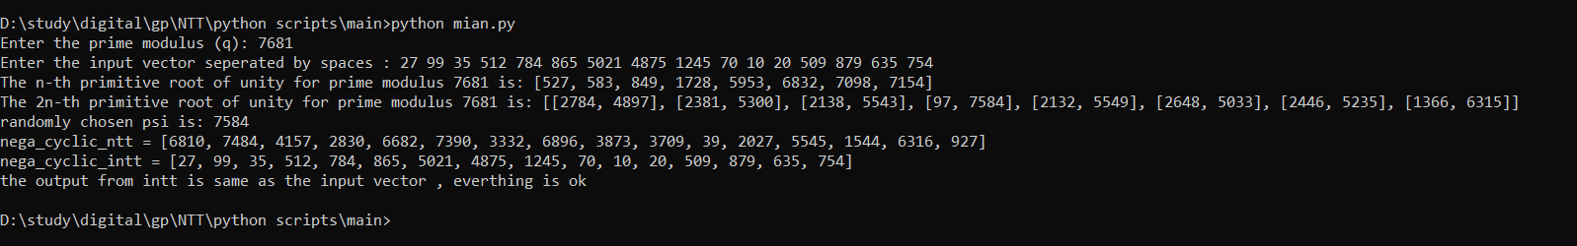 

*Figure 5: Python Model Validation Results*

### 7.2 Pre-Optimization SDF-NTT Performance

The basic operation characteristics, including latency and throughput measurements, were evaluated for the initial implementation.

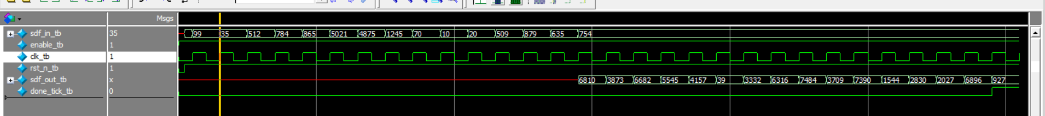

*Figure 6: Pre-Optimization SDF-NTT Performance Metrics*

**Note: The hardware implementation outputs data in bit-reversed order, whereas the Python reference model produces results in natural order it will be handled in the transcript in the final version of the system in section 7.3 and 7.4.**

As shown in the wave form the first output comes out with feeding in the last input and no latency between the output points.

### 7.3 Post-Optimization Pipelining Validation

The effectiveness of the 4-stage pipelining optimization was validated through comprehensive simulation tests.

**Note: we add an extra flip-flop at the input of each butter fly unit stage to increase frequency.**

**NTT Test:**

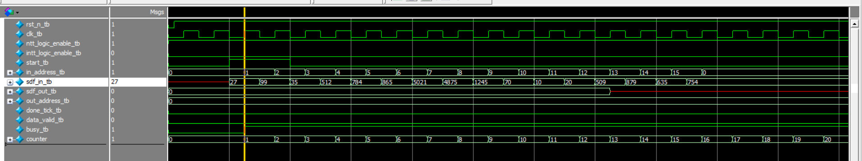

*Figure 7: NTT input vector snapshot*

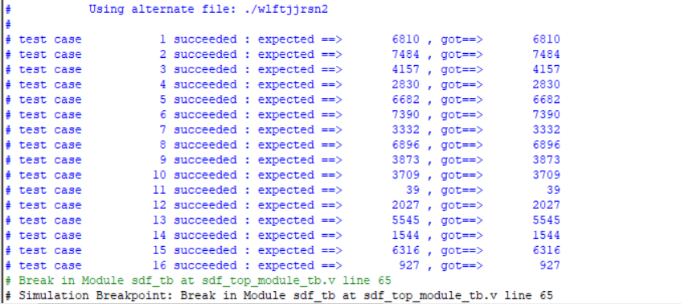

*Figure 8: Post-Optimization Pipeline NTT Validation Results*

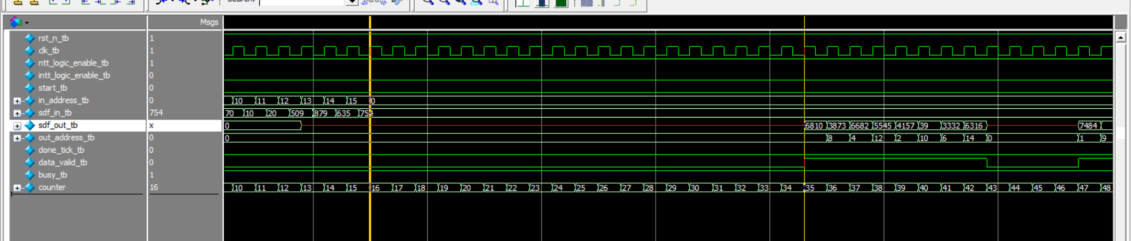

*Figure 9: first output latency*

**As shown in this snapshot there is a resulted latency between the last input and first output.**

**The delay till the first output comes out = number of pipeline stages + number of stalling cycles + buffer size of 1st stage + size of polynomial + added latecy due to the flip-flop at the input -1 .**

**= 4 + 4 + 8 + 16 + 4 -1 = 35.**

**Since the output port is in the last stage (4th stage) so this latency is 4 cycles**

**So the latency= 35 – the delay of the last input = 35 -16 = 19 cycles.**

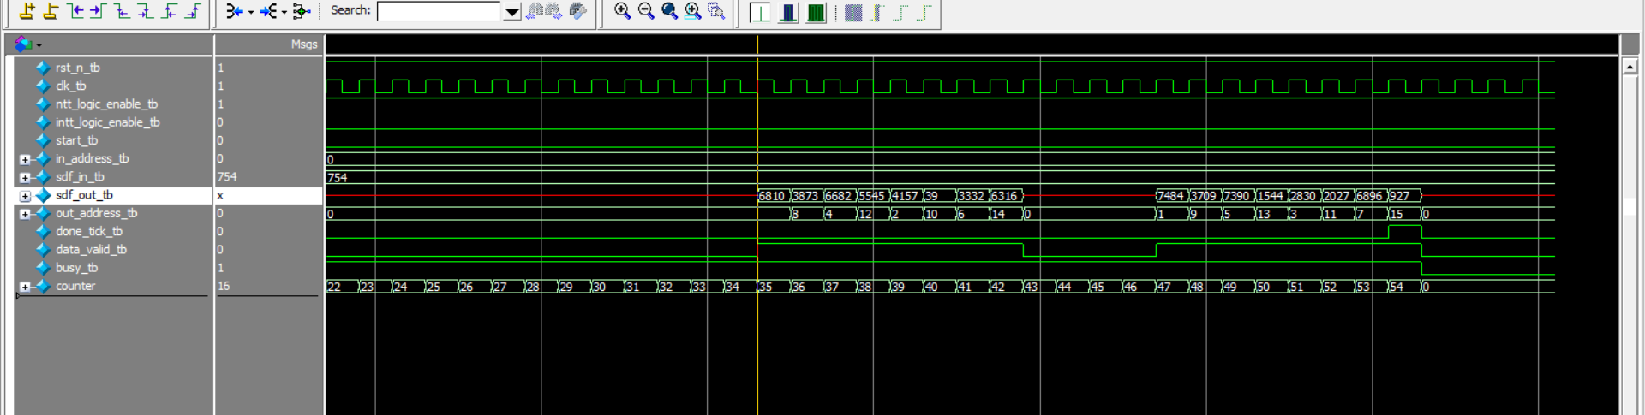

*Figure 10: second bunch of data latency*

**Also we have an added latency between the first halve of the output data and the second halve of the output data**

**This latency = the number of the pipeline stages =4 cycles.**

**INTT Test:**

**Same behavior as the NTT but with different inputs and outputs**

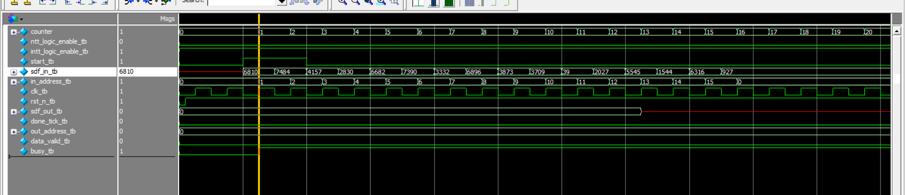

*Figure 11: INTT input vector snapshot*

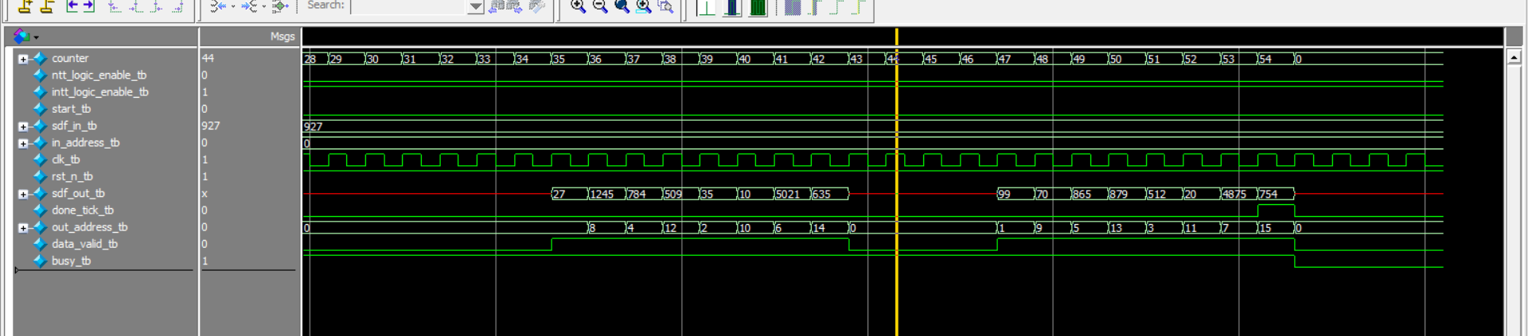

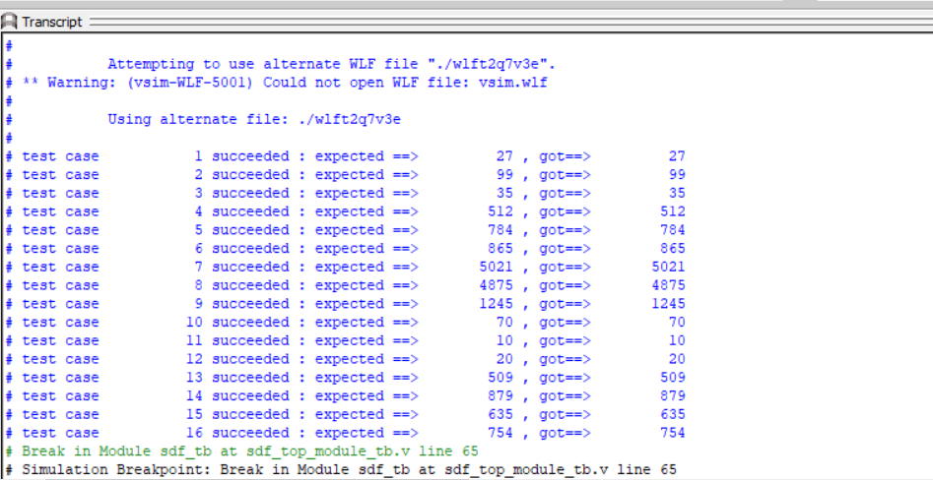

*Figure 12: Post-Optimization Pipeline INTT Validation Results*